# CS 255 Business Requirements Document Template

Complete this template by replacing the bracketed text with the relevant information.

This template lays out all the different sections that you need to complete for Project One. Each section has guiding questions to prompt your thinking. These questions are meant to guide your initial responses to each area. You are encouraged to go beyond these questions using what you have learned in your readings. You will need to continually reference the interview transcript as you work to make sure that you are addressing your client’s needs. There is no required length for the final document. Instead, the goal is to complete each section based on your client’s needs.

**Tip:** You should respond in a bulleted list for each section. This will make your thoughts easier to reference when you move into the design phase for Project Two. One starter bullet has been provided for you in each section, but you will need to add more.

## System Components and Design

### Purpose

*What is the purpose of this project? Who is the client and what do they want their system to be able to do?*

* The client is "DriverPass," and its goal is to provide better driver training to help students pass their driving tests at the DMV.
* DriverPass is looking to offer online classes, practice tests, and on-the-road training sessions to their customers.
* The purpose of this project is to design and develop a system that allows DriverPass to manage these services efficiently and effectively.
* The system should enable customers to access online materials, schedule driving lessons, and track their progress online.
* The system must also allow certain users to access data offline by downloading reports and information to work on from anywhere.
* Our goal is to build a system that meets DriverPass's needs for data accessibility, security, and functionality that not only provides better driver training but also improves the success rates of the students.

### System Background

*What does DriverPass want the system to do? What is the problem they want to fix? What are the different components needed for this system?*

* DriverPass wants its system to provide robust driver training that improves the success rate of students taking their DMV driving tests.

**Problem DriverPass Wants to Fix**:

* DriverPass is looking to decrease the high failure rate among driving test takers, which they believe is due to insufficient preparation and poor training resources.

**Solution Offered to This Problem**:

* Providing online classes and practice tests to prepare students for the written portion of the driving test.
* Offering on-the-road training sessions with certified instructors for practical driving experience.

**Components Required for DriverPass’s System:**

* Online course management for delivering educational content and practice exams.
* Scheduling system for customers to book, modify, or cancel driving lesson appointments.
* User account management with different roles and access levels.
* Tracking and reporting tools to monitor user activities and generate reports.
* Integration with DMV systems for updates on rules, policies, and sample questions.
* A cloud-based infrastructure to allow for online access from any device and external management of backups and security.
* User-friendly interface that aligns with the client's design preferences, which also includes test progress tracking and driver notes display.

### Objectives and Goals

*What should this system be able to do when it is completed? What measurable tasks need to be included in the system design to achieve this?*

* Allow users to access the system from any computer or mobile device.
* Provide the ability to download reports and data for offline use and work.
* Create a user account system with different access levels and roles.
* Ensure secure handling and storage of user credentials and personal information.
* Provide functionality to reset passwords and block or modify user access as needed.
* Allow for the assignment and management of user roles within the system.
* Log all user actions, including creating, modifying, or canceling reservations.
* Enable users to schedule, modify, or cancel driving lesson appointments online.
* Support appointment scheduling via phone or in-person assistance.
* Match and track assignments between customers, drivers, times, and vehicles.
* Provide access to online classes and practice tests for users.
* Display user progress on tests, including test names, time taken, scores, and status.
* Show driver comments and feedback to users.
* Present detailed lesson information, including lesson times and start and end hours.
* Gather necessary customer details such as name, contact information, pickup/drop-off locations, and payment information.
* Ensure all sensitive data is securely stored and complies with data protection regulations.
* Protect against unauthorized access, data breaches, and other security threats.
* Integrate secure payment systems to handle credit card information safely.
* Receive and incorporate updates on new DMV rules, policies, and sample questions.
* Operate the system over the web using cloud services.
* Design the interface to align with the client’s preferences.
* Design the system to be modular for future modifications or additions of packages with minimal developer intervention.
* Ensure system performance is optimized for a smooth user experience.
* Maintain accurate and consistent records across the system.

## Requirements

### Nonfunctional Requirements

*In this section, you will detail the different nonfunctional requirements for the DriverPass system. You will need to think about the different things that the system needs to function properly.*

#### Performance Requirements

*What environments (web-based, application, etc.) does this system need to run in? How fast should the system run? How often should the system be updated?*

* The DriverPass system must run as a web-based application to ensure accessibility from any device with internet access. The system should load pages quickly, approximately two seconds or less, to ensure efficiency and user satisfaction.
* Fast performance enhances user experience and encourages continued system use. According to Dennis et al. (2012), nonfunctional requirements include performance aspects that “describe the system’s quality attributes.”
* The system for DriverPass's application should be updated monthly to incorporate new features, fix bugs, and address any security vulnerabilities.

#### Platform Constraints

*What platforms (Windows, Unix, etc.) should the system run on? Does the back end require any tools, such as a database, to support this application?*

* DriverPass's application should be compatible with major operating systems, which include Windows, macOS, Linux, Android, and iOS. This will ensure that DriverPass can reach the broadest possible user base.
* Compatibility among all of these operating systems ensures that users can access the system from various devices. Dimitris (2020) states that nonfunctional requirements "define attributes or characteristics that the final solution needs to have."

#### Accuracy and Precision

*How will you distinguish between different users?* *Is the input case-sensitive? When should the system inform the admin of a problem?*

* The system will distinguish between users by assigning unique usernames or IDs and linking them to their respective roles (e.g., admin, IT officer, secretary, customer). Usernames will be treated as case-insensitive, while passwords will be case-sensitive for security. The system should inform the admin when there are repeated unsuccessful login attempts (potential brute force attacks), unauthorized data modifications, or data integrity checks fail—essentially, any suspicious activity that could compromise accuracy or data quality.

#### Adaptability

*Can you make changes to the user (add/remove/modify) without changing code? How will the system adapt to platform updates? What type of access does the IT admin need?*

* All user management can be done through an administrative dashboard without direct code changes, such as adding, removing, or modifying users. The system’s modular design and use of cloud-based services enable it to adapt quickly to platform updates, including regular security patches and feature enhancements. The IT admin needs full administrative access to user accounts, system configurations, and the ability to enable or disable certain features, ensuring that necessary changes can be made efficiently without developer intervention.

#### Security

*What is required for the user to log in? How can you secure the connection or the data exchange between the client and the server? What should happen to the account if there is a “brute force” hacking attempt? What happens if the user forgets their password?*

* Users must provide a valid username and password to log in. Passwords will be encrypted at rest, and data exchanged between client and server will be secured using HTTPS with TLS encryption. In the event of a brute force hacking attempt, the account will be temporarily locked, and an alert will be sent to the admin. If the user forgets their password, they will be able to reset it through an automated password recovery system, typically via a secure link sent to their registered email.

### Functional Requirements

*Using the information from the scenario, think about the different functions the system needs to provide. Each of your bullets should start with “The system shall . . .” For example, one functional requirement might be, “The system shall validate user credentials when logging in.”*

* The system shall validate user credentials when logging in.
* The system shall allow customers to schedule and modify driving lesson appointments online.
* The system shall track and record each reservation, including who made or changed it and when.
* The system shall provide multiple training packages and allow the admin to enable, disable, or update them.
* The system shall integrate with DMV data to receive updates on rules, policies, and practice test questions.
* The system shall store and display customer data, test progress, and instructor notes.
* The system shall support password reset functionality for users who have forgotten their passwords.

### User Interface

*What are the needs of the interface? Who are the different users for this interface? What will each user need to be able to do through the interface? How will the user interact with the interface (mobile, browser, etc.)?*

* Admin/IT Officer: Manage user accounts, adjust system settings, and review reports.
* Secretary: Input customer data from phone calls, schedule appointments, and handle administrative tasks.
* Customer: Register, schedule lessons, view online classes, take practice tests, and review progress.
* All users will interact with the system through a secure, browser-based interface with a responsive design for mobile compatibility.

### Assumptions

*What things were not specifically addressed in your design above? What assumptions are you making in your design about the users or the technology they have?*

* It is assumed that users have stable internet access and use a compatible device (e.g., a computer, tablet, or smartphone) capable of running modern web browsers. We assume that administrators and IT staff have the necessary training to manage system configurations and user accounts. We also assume third-party integrations (like DMV updates) are available and responsive. Additionally, we assume compliance with relevant data protection laws and that the user base understands basic web navigation.

### Limitations

*Any system you build will naturally have limitations. What limitations do you see in your system design? What limitations do you have as far as resources, time, budget, or technology?*

* Limitations may include dependency on consistent internet connectivity for full functionality, potential downtimes due to maintenance or cloud provider issues, and constraints around budget or time that limit immediate development of advanced features like fully customizable training packages by non-developers. Integration with external entities (such as the DMV) relies on their uptime and data quality. Performance may also be constrained by the resources allocated to the hosting environment, and scalability might require additional investment in infrastructure.

### Gantt Chart

*Please include a screenshot of the GANTT chart that you created with Lucidchart. Be sure to check that it meets the plan described by the characters in the interview.*

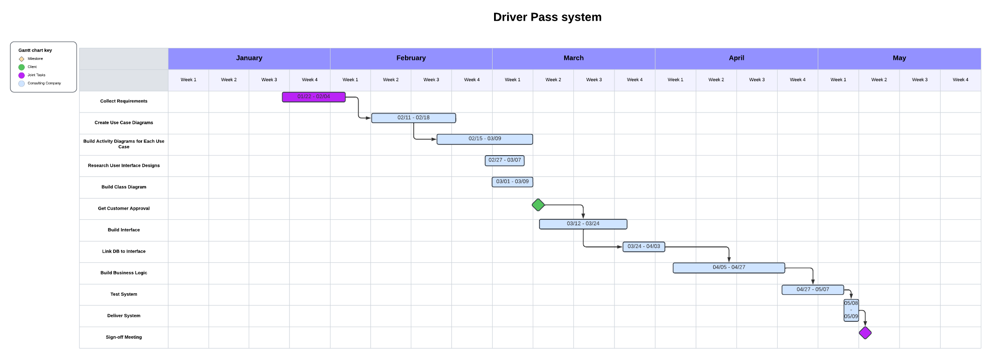

**References**

Dennis, A., Wixom, B. H., & Tegarden, D. (2012). *Systems analysis and design with UML* (4th ed.). Wiley.

Dimitris. (2020, August 27). *Business requirements vs functional requirements*. Retrieved from https://example.com/business-requirements-vs-functional-requirements